Payload Electronics — Component Research
Sensor picks, system diagram, MCU choice, storage plan, risks, and fall next steps

Sensors

Pressure & temperature
Same chip measures both.
Spec | MS5611 | BMP390
Accuracy | ±1.5 mbar (≈ 10 cm altitude) | ±3 Pa (≈ 0.25 m altitude)
Speed | 100+ Hz | up to ≈200 Hz
Interface & power | I2C/SPI, <1.4 mA | I2C/SPI, <650 µA
Cost | ≈ $10 | ≈ $10
Pick: MS5611 — the standard altimeter chip in student rocketry. BMP390 is the backup.

Vibration
Measures shock and vibration through flight, including ignition and parachute deployment.
Spec | ADXL375 | ICM-42688-P
Range | ±200 g | ±16 g max
Bandwidth | ≈ 1 kHz | up to ≈1.6 kHz+
Interface & power | I2C/SPI, ≈145 µA | I2C/SPI/I3C, ≈0.88 mA
Cost | ≈ $15 | ≈ $15–$35
Pick: ADXL375 — ±200 g range, won't clip on shock. ICM-42688-P adds spin/attitude data if the team wants it later, but its ±16 g range risks clipping.

Humidity
Adds relative humidity to the pressure/temperature reading.
Spec | SHT40 | BME280
Accuracy | ±1.8% RH, ±0.2 °C | ±3% RH, ±1 hPa pressure
Also measures | Humidity & temperature only | Humidity, temperature, and pressure
Interface & power | I2C, low power | I2C/SPI, low power
Cost | ≈ $6–$8 | ≈ $8–$10
Pick: SHT40 — more accurate than BME280, and keeps MS5611 as the pressure sensor.

GPS / position
Timestamps and geotags every reading. Wind speed and direction come from horizontal drift during the parachute descent.
Spec | NEO-M9N | NEO-M8N
Accuracy | ≈ 1.5 m, 4 satellite systems at once | ≈ 2.5 m, up to 3 systems at once
Update rate | up to 25 Hz | up to 10 Hz
Interface & power | I2C/UART, ≈31 mA tracking | UART/I2C, similar draw
Cost | ≈ $70 (full-featured breakout) | ≈ $20–$30 (common breakout)
Pick: NEO-M8N — cheaper, and accurate enough for this. Consumer GPS chips cap around 4 g / 500 m/s, so expect a brief loss of lock during motor boost. Mount the antenna on fiberglass or plastic — carbon fiber blocks GPS signal.

System Diagram
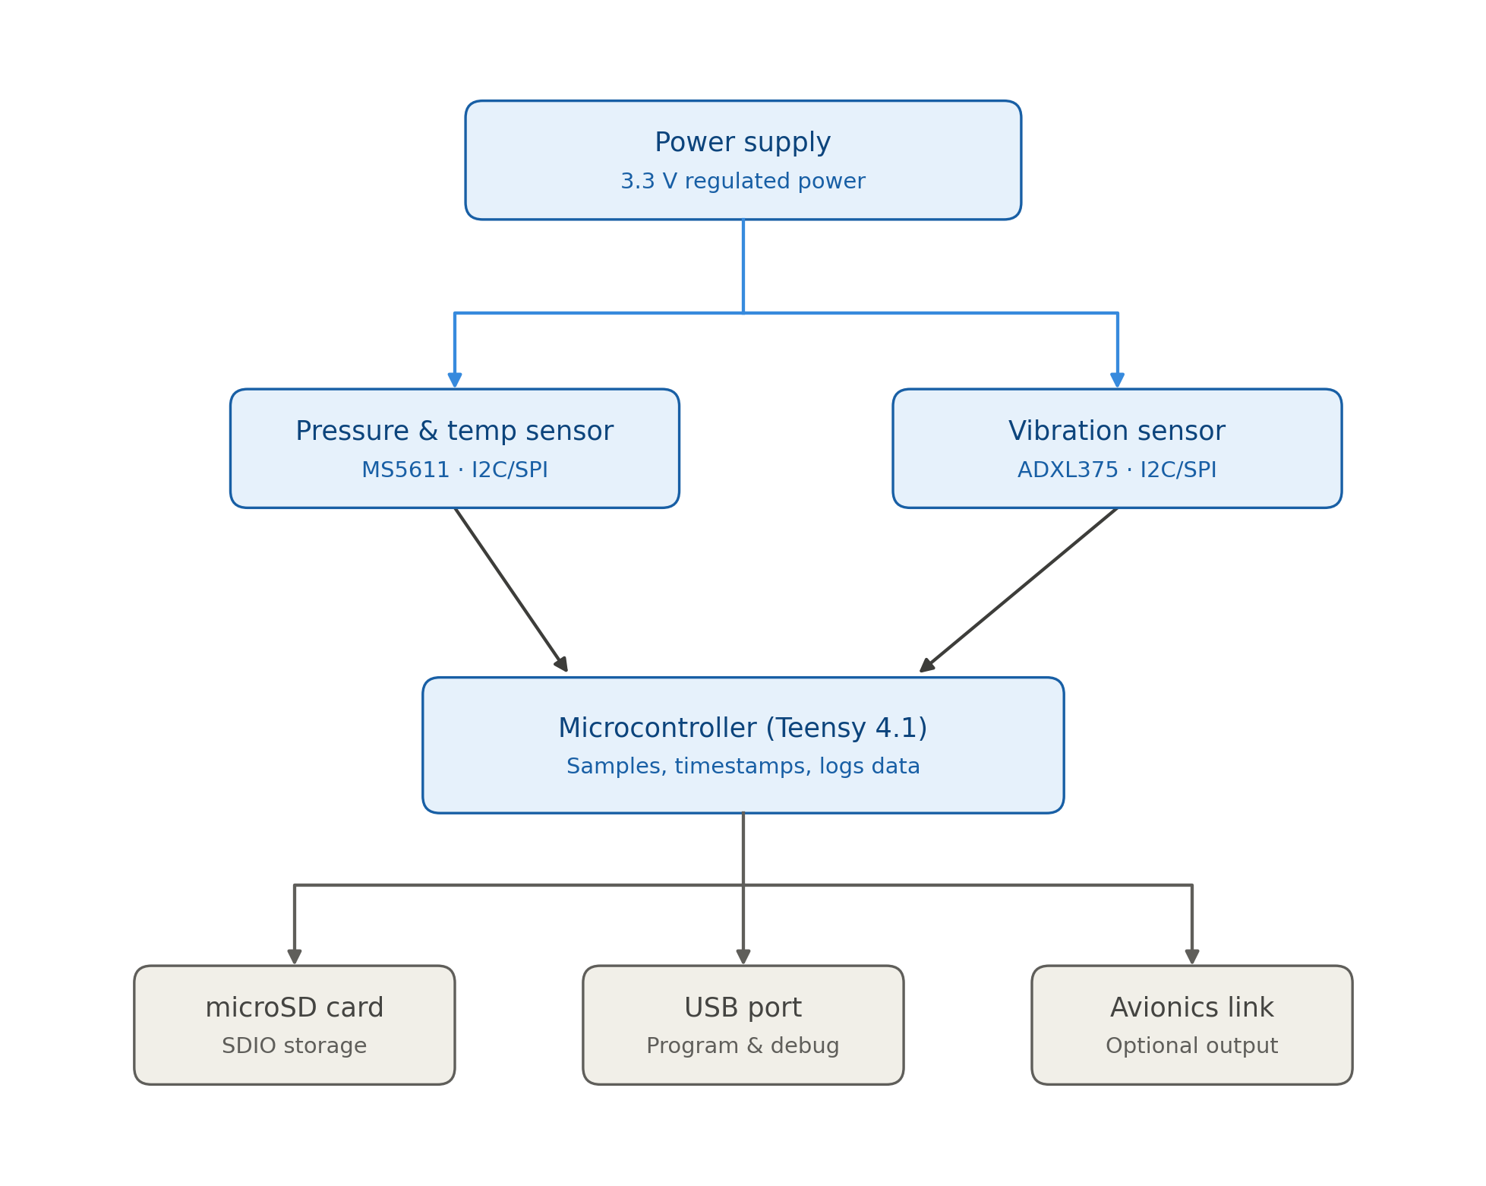
Power flows from the regulator to both sensors and the microcontroller. Sensors report over I2C/SPI to the Teensy, which timestamps and logs each sample to the microSD card. USB handles programming; the avionics link is optional.

Microcontroller: Teensy 4.1 vs. ESP32
Spec | Teensy 4.1 | ESP32
Speed | 600 MHz, single core | 240 MHz, dual core
Memory | 1 MB RAM / 8 MB flash | 520 KB RAM / 4 MB flash
SD card | Built-in, fast slot | Usually slower; shares pins with flash
Radio | None — quieter near GPS/altimeter | Wi-Fi + Bluetooth always on board
Timing | Nothing competes for CPU time | Background Wi-Fi tasks can add jitter
Price | ≈ $31.50 | ≈ $10.00
Pick: Teensy 4.1 — cleaner sampling loop, built-in SD slot, no radio nearby. ESP32 is the pick for wireless telemetry or a tight budget.

Storage Plan
Channel | Rate | Data per flight
Pressure & temp | 100 Hz | ≈ 0.6 MB
Vibration | 800 Hz | ≈ 4.8 MB
Total (packed binary) | — | ≈ 5.4 MB
As plain-text CSV instead of packed binary: ≈ 30–45 MB per flight. An 8–32 GB microSD card covers a full season many times over. The Teensy timestamps every sample from one shared clock, so pressure and vibration data stay aligned.

Major Risks
- Sensor clipping — not enough range cuts off shock data.
- Power sag at ignition — give the regulator margin to avoid a reset.
- Slow SD writes — buffer in RAM so a slow write doesn't drop a sample.
- Loose wiring — use locking connectors and strain relief.
- Shared-bus lockup — split sensors across separate I2C/SPI buses.
- Corrupted log file — flush/close the file periodically.
- Radio noise — keep sensor wiring short and away from trackers or altimeters.

Fall Next Steps
- Breadboard the MS5611 + ADXL375 on the Teensy 4.1 and confirm logging works at full speed.
- Measure real power draw, size the battery and regulator, and test recovery from a brief power dip.
- Shake-test the prototype (or fly it non-critically) to confirm mounting and sample rates actually capture what we need.

Sources
Datasheets and vendor pages: TE Connectivity/Amsys MS5611-01BA03; Bosch Sensortec BMP390 and BME280; Analog Devices ADXL375 and ADXL377; TDK InvenSense ICM-42688-P; Sensirion SHT4x; u-blox NEO-M9N and NEO-M8N; PJRC/SparkFun Teensy 4.1; Espressif ESP32-DevKitC-32E.

